Exploring Sarvam AI Postman Collections through Rest API
Chat Completions (sarvam-30b)
Parameter | Location | Default / Sample value
model | JSON body | sarvam-30b/sarvam-105b
messages[0].role | JSON body | user
messages[0].content | JSON body | Namaste! Explain UPI in one sentence.
temperature | JSON body | 0.7
stream | JSON body | false
Content-Type | Header | application/json
api-subscription-key | Header | {{apiSubscriptionKey}}
baseUrl | Variable | https://api.sarvam.ai
url | Path | {{baseUrl}}/v1/chat/completions

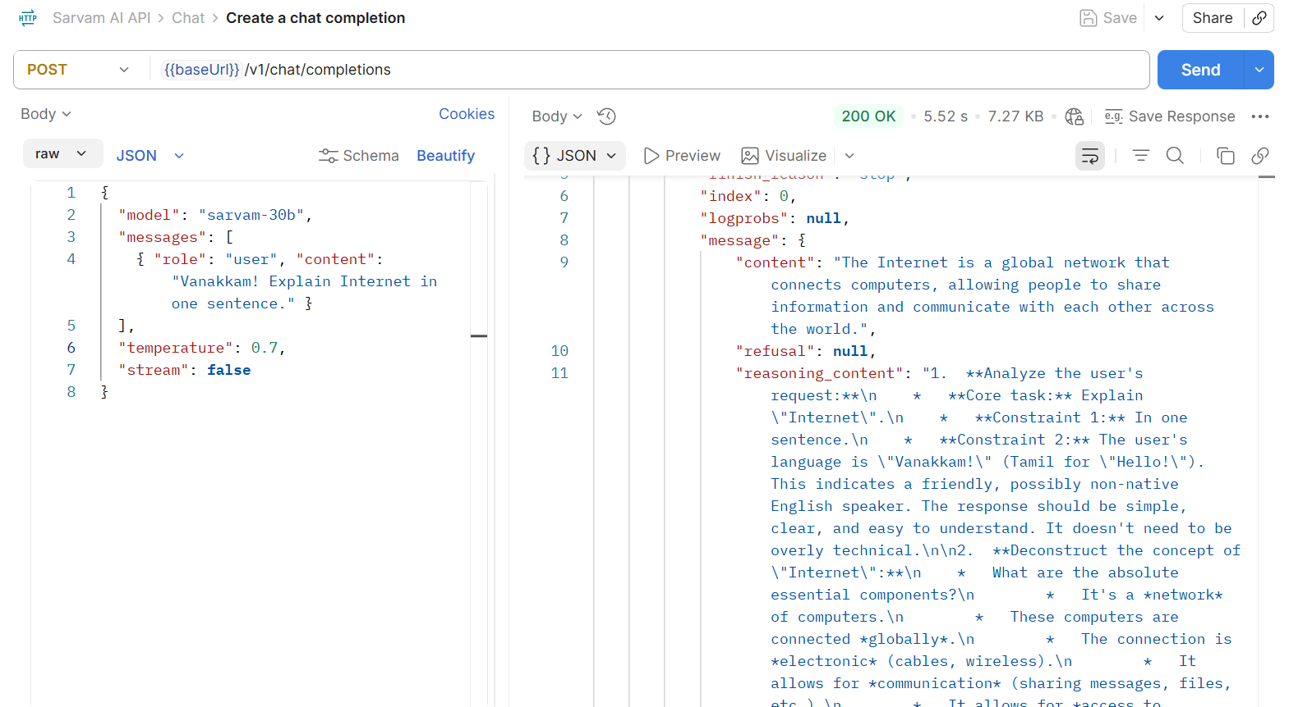
Speech to Text (saaras:v3) :Translate and Transcribe
Parameter | Location | Default / Sample value
file | form-data | (empty, choose file in Postman)
model | form-data | saaras:v3
language_code | form-data | hi-IN
api-subscription-key | Header | {{apiSubscriptionKey}}
baseUrl | Variable | https://api.sarvam.ai
url | Path | {{baseUrl}}/speech-to-text

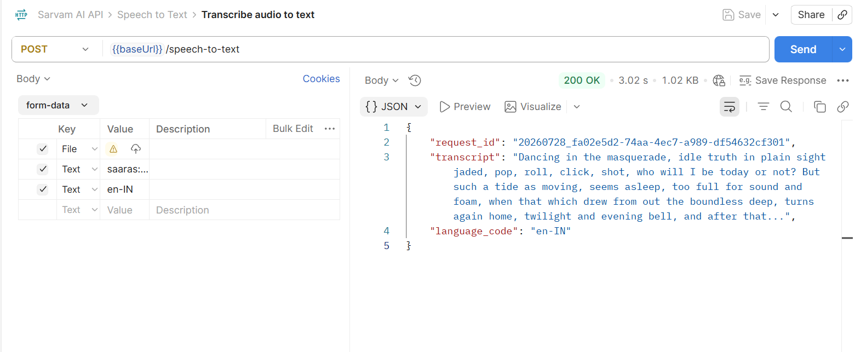

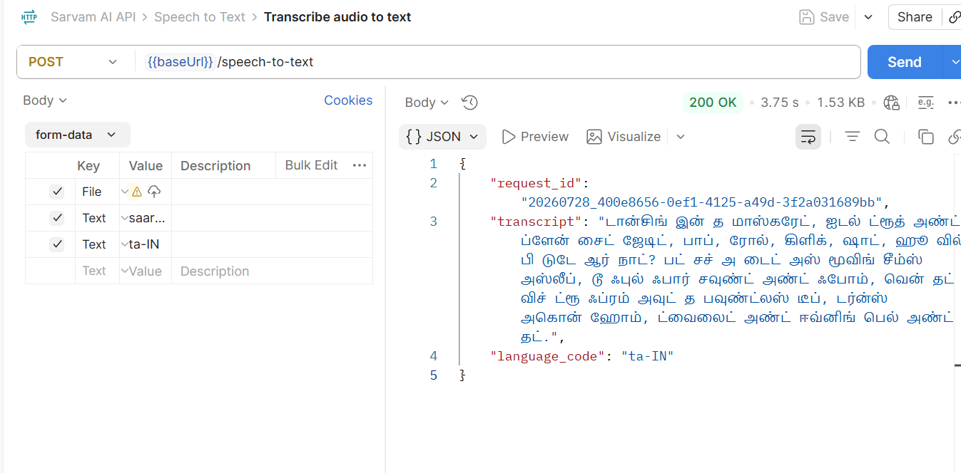

Text to Speech (Bulbul v3)
Parameter | Location | Default / Sample value
text | JSON body | नमस्ते, आप कैसे हैं?
target_language_code | JSON body | hi-IN
model | JSON body | bulbul:v3
speaker | JSON body | shubh
output_audio_codec | JSON body | wav
Content-Type | Header | application/json
api-subscription-key | Header | {{apiSubscriptionKey}}
baseUrl | Variable | https://api.sarvam.ai
url | Path | {{baseUrl}}/text-to-speech
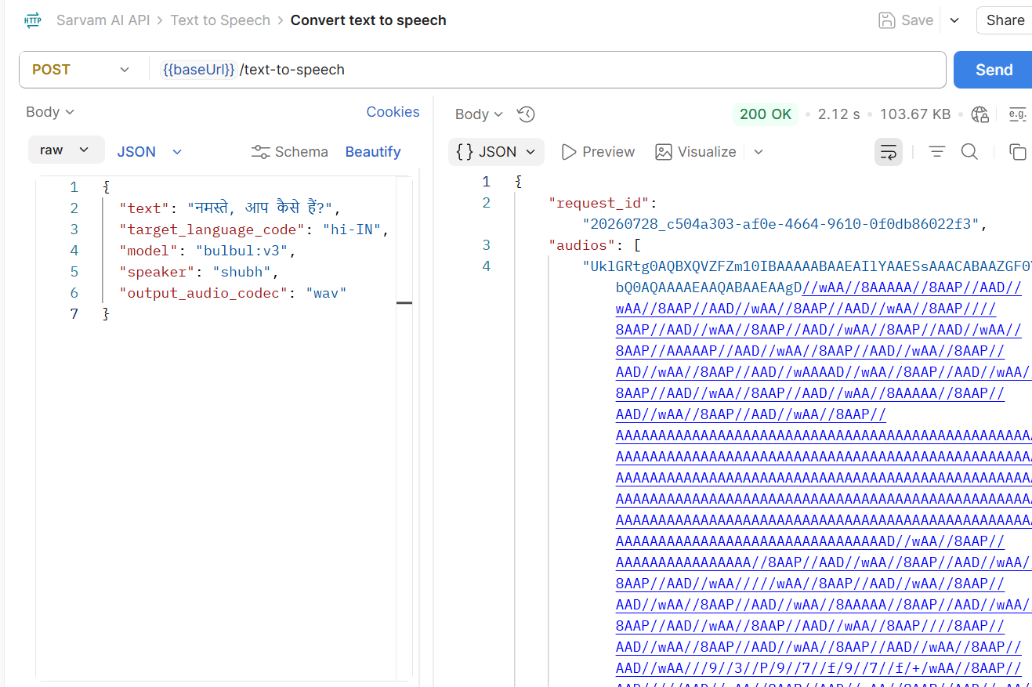
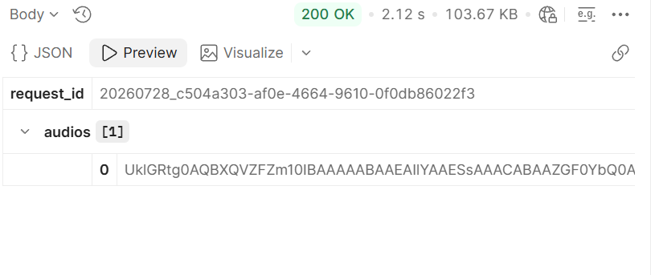

Translate: Text Between Languages (Mayura:v1)
Parameter | Location | Default / Sample value
input | JSON body | How are you?
source_language_code | JSON body | en-IN
target_language_code | JSON body | hi-IN
model | JSON body | mayura:v1
Content-Type | Header | application/json
api-subscription-key | Header | {{apiSubscriptionKey}}|
baseUrl | Variable | https://api.sarvam.ai|
url | Path | {{baseUrl}}/translate|

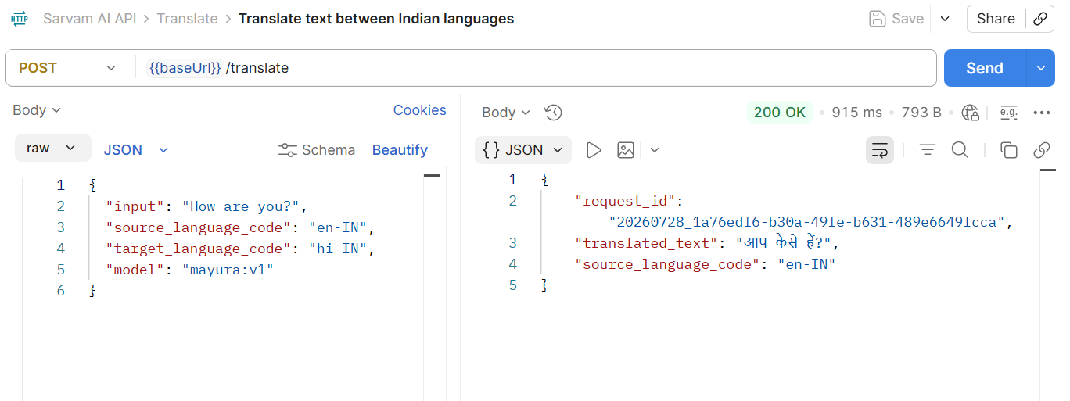
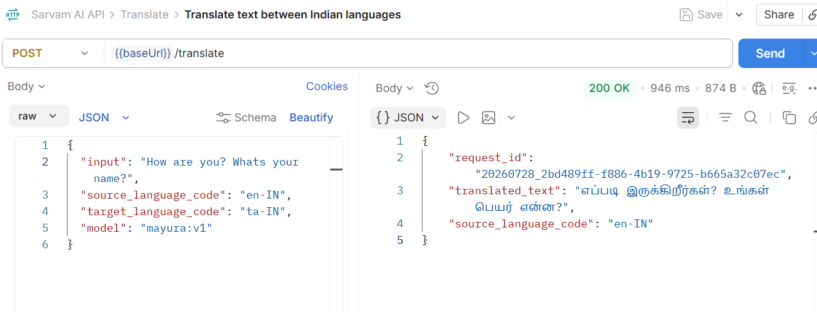

Transliterate
Parameter | Location | Default / Sample value
input | JSON body | namaste
source_language_code | JSON body | en-IN
target_language_code | JSON body | hi-IN
numerals_format | JSON body | international
Content-Type | Header | application/json
api-subscription-key | Header | {{apiSubscriptionKey}}|
baseUrl | Variable | https://api.sarvam.ai|
url | Path | {{baseUrl}}/transliterate|
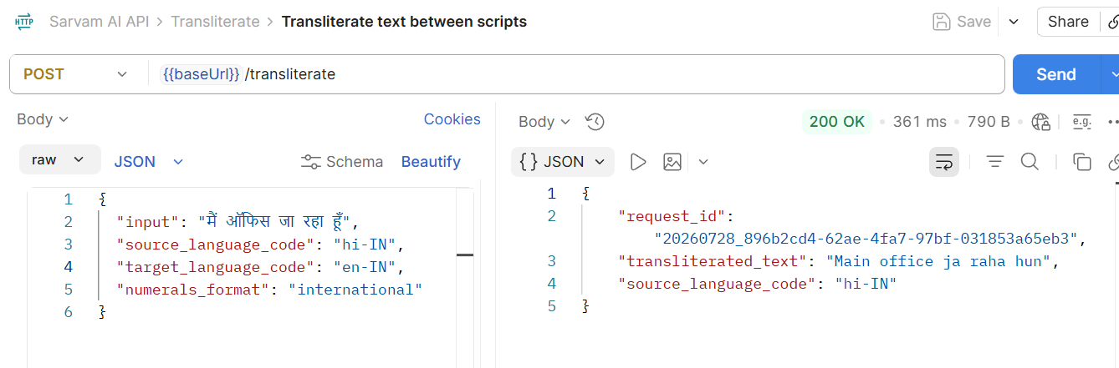

Language Identification
Parameter | Location | Default / Sample value
input | JSON body | आप कैसे हैं?
Content-Type | Header | application/json
api-subscription-key | Header | {{apiSubscriptionKey}}|
baseUrl | Variable | https://api.sarvam.ai|
url | Path | {{baseUrl}}/text-lid|

